JOHNNIE JONES CLASSIC
GOLF TOURNAMENT

May 20, 2023
FOREST HILL GOLF COURSE
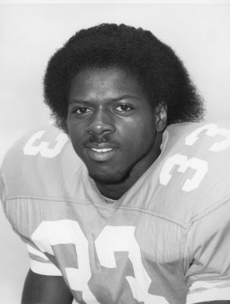

Name of Contact Person Business Name

Phone Number Email Address

Sponsor Level
Hole Sponsor ($100)
Team Sponsor ($320)
Corporate Sponsor ($300)
Flight Sponsor ($500)
Tournament Sponsor ($1000)
Beverage Cart Sponsor ($150)

- Make Checks Payable to Munford Touchdown Club

- Return Via Mail to:
Munford High School
C/O Johnnie Jones Classic
1080 McLaughlin Dr.
Munford TN 38058

- Contact Us for More Information
Donnie Kelley: (706) 994 – 1961
www.jjclassic.weebly.com

Business Representative’s Signature

